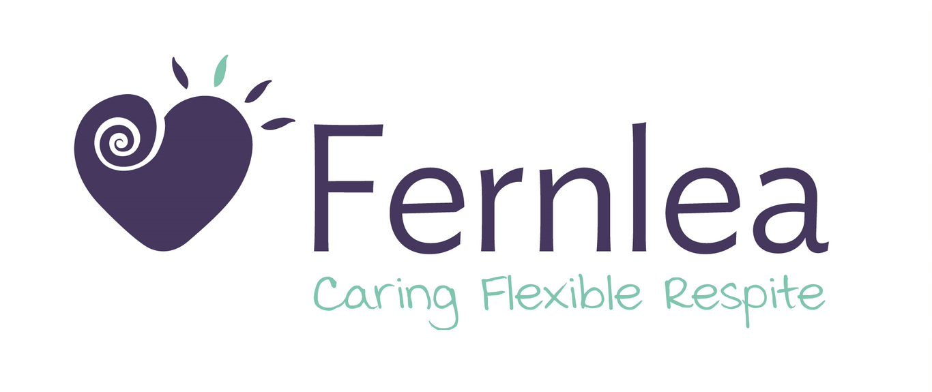

EMPLOYMENT

Personal Care Assistants (PCA) / In-Home Care Support

Fernlea Community Care Inc. provides Day Respite for people with life limiting illness, chronic conditions and dementia, and for their carers. With Day Respite centres in Emerald and Pakenham, and an In-Home service that covers the South-Eastern suburbs, our primary focus is to deliver the best possible standard of care to our clients and their families.

We are currently seeking passionate and committed Personal Care Assistants (PCA) and In-Home Care Support services.

To be considered for this role, you must have:
- Certificate III in Individual Support (or equivalent Aged Care, Home and Community Care or Disability Support) and/or Certificate IV in Ageing Support and/or in Disability
- In-Home services - Significant previous experience working independently and without direct supervision, in an in-home setting; experience in palliative care or dementia is desirable
- A genuine caring and client-centred approach to your work
- Outstanding communication, observational and reporting skills
- Excellent time management with a proactive attitude
- Demonstrated ability to work alone and as part of a team
- Current Victorian Drivers Licence and own reliable vehicle
- Current Police Check or willingness to undergo and a valid Australian Working Visa
- Proof of Vaccination against COVID 19 (3 Doses)

If you have a genuine passion for making a difference in the lives of people with a life-limiting illness and their carers we look forward to hearing from you.

Please send a Covering Letter and Resume to Sharon at admin@fernlea.com.au

